**HanzeHogeschool Groningen**

15

**Individual Quizgame**

**roy leinenga**

**CSV1B**

Inhoud

Game Design 2

Verb analysis 2

Question 2

Check Answer 2

Main 2

Start Screen 2

End Screen 2

High Scores 2

Flow Chart 3

Wireframe sketch 4

Main menu 4

Questions 4

Ending screen 5

High scores 5

Class Diagram 6

# Game Design

For this game I’m going to create a quiz where pictures of rollercoaster are viewed and the player has to fill in the correct answer of where this rollercoaster is located. The player has to fill in the correct answer in the given amount of time. Once the player starts up the game he will be showed a start screen where he can choose to if he wants to play the game, view the high scores or if he wants to exit the game. If the player chooses to start the game, the game will show a short introduction and then show the first question which it fetches from the database. Then the player can choose an answer by pushing the 1,2 or 3 on your keyboard. If the player choses the correct answer 100 points plus the amount of time left will be added to their score and the game will continue to the next question. But if the player chooses the wrong answer the game will continue say to the player that he answered the wrong answer and continue to the next question without adding any points to the players score. Once the player finished all of the question the game will present the players score and give and add it to the high scores. The game will also give the player buttons to view the high scores, return to the main menu or to exit the game.

# Verb analysis

Nounce Verbs

|  |  |
| --- | --- |
| Player | Display |
| Question (m.c) | Retrieve |
| Question (text) | Store |
| Timer | Anwer |
| Score | Recieve |
| Database |  |
| Sequence | Play |
| Puzzle | Gains |
| Answer options |  |
| High | Presented |
| Point | list |

## Question

The game gives the player questions fetched from a database. I decided to do this in a different class in order to keep the code more organized.

## Check Answer

This class checks if the player chose the correct or wrong answer and ads points if nesecairy. This class also calls for the creation of the next question.

## Main

The main class is the class where the main game is created and a database connection is made. This class also stores some of the most important variables to be used by the different classes.

## Start Screen

This class will create the start screen for the game with the main buttons to start the game, view the high scores or end the game.

## End Screen

This class will create the end screen with the buttons to return to the main menu, view the high scores or end the game. This class will also display your end score.

## High Scores

This class will create the screen where you can view other peoples end scores, it will also create buttons to exit the game or to return to the main menu.

# Flow Chart

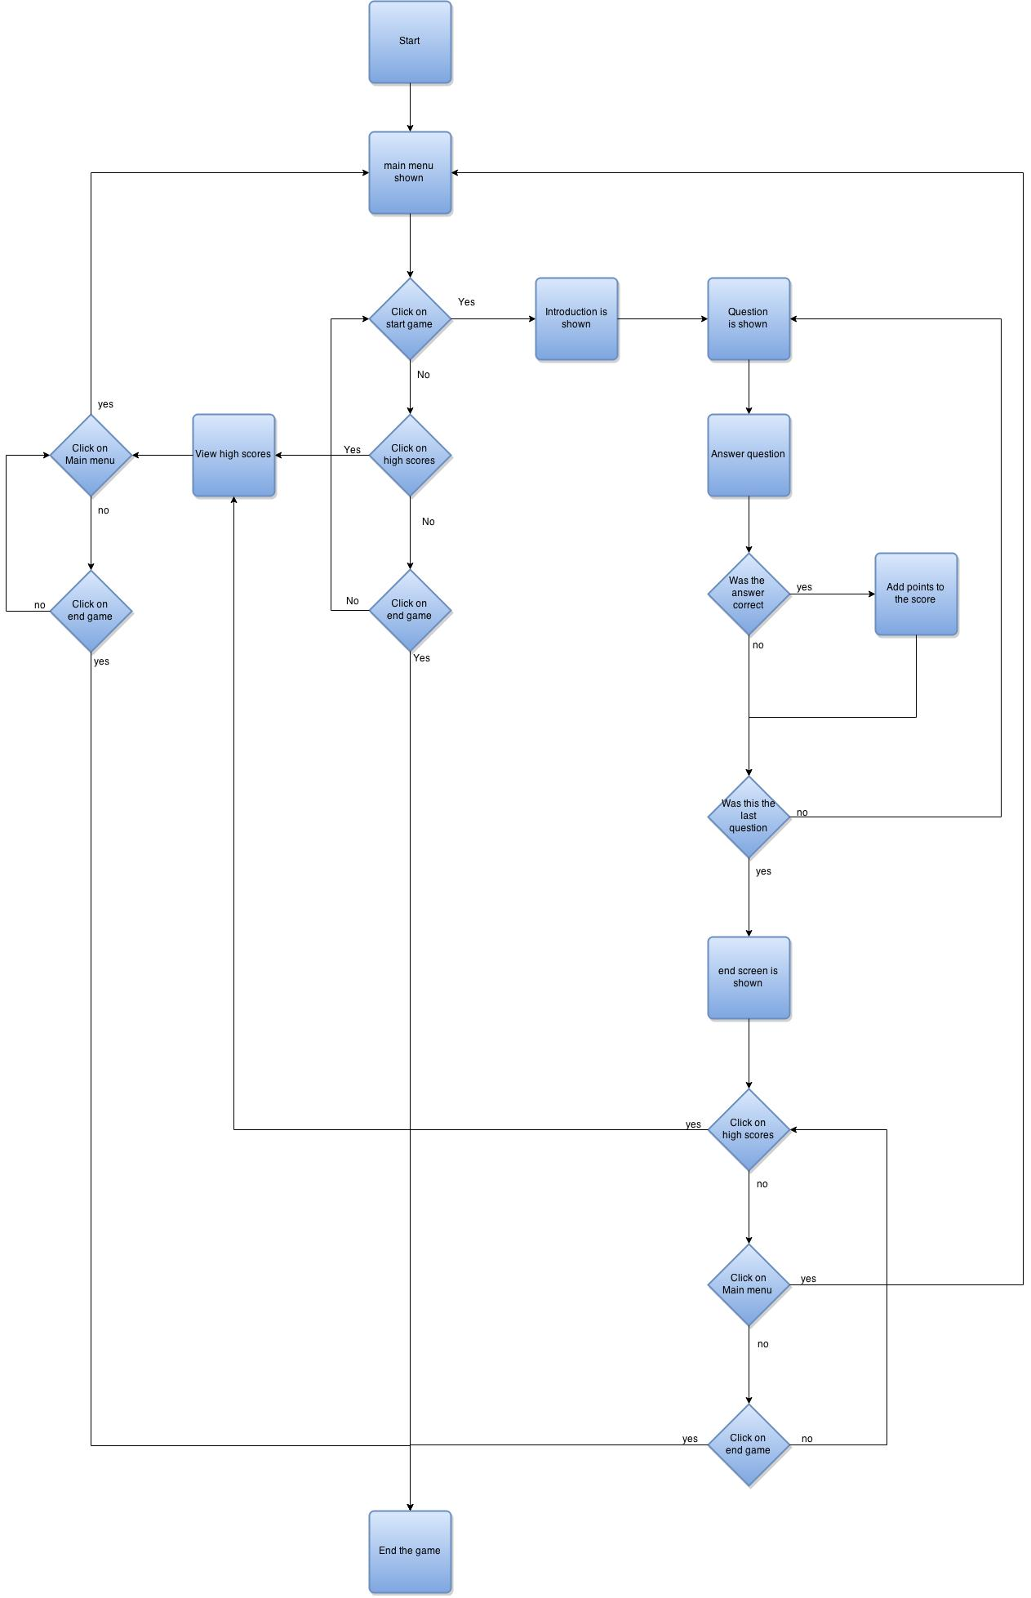

Once the player started the game he is shown with the main menu where he can choose to start the game, view the high scores or end the game. If the player chose to start the game a short introduction is shown and then the questions start. The player is shown a question with three possible answers where the player can choose from. Once the player chose an answer it is checked and if he had the correct answer a small feedback screen if shown after which points are added to his score and the next question is shown. If the player guessed wrong a small feedback screen is shown after which the next question is shown without adding anything to the score. If the player answered all the question an ending screen with the players score is shown. On this screen the player can choose to view the high scores, return to the main menu or end the game. If the player chooses to view the high scores a screen with the high scores is shown. On this screen the player can choose to return to the main menu or end the game.

# Wireframe sketch

## Main menu

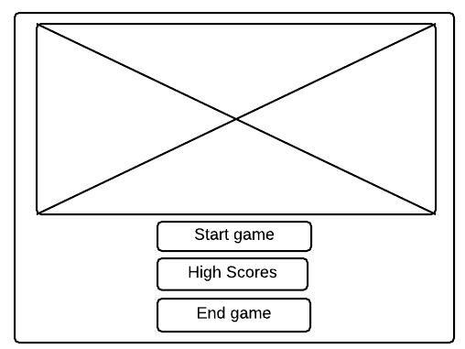

The main menu consist of a large picture in the top with the menu buttons below.

## Questions

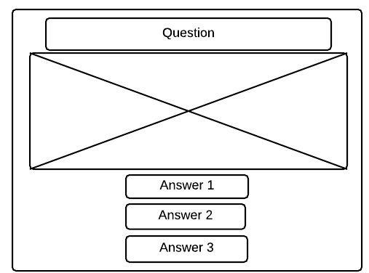

The question screen consists of the question on the top and the picture below that and at the bottom are the three possible answers.

## Ending screen

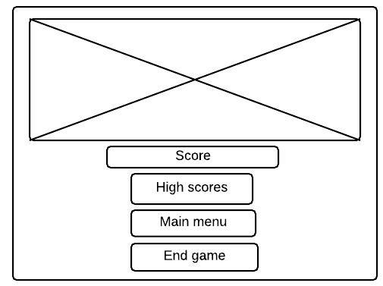

The ending screen consists of a picture on the top with the players score below that. On the bottom are the different menu buttons.

## High scores

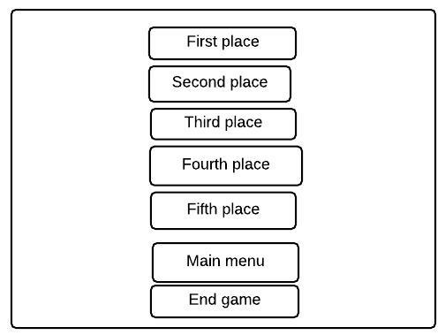

The high Score screen consists of the 5 leading scores on the game and below that the menu buttons.

# Class Diagram

